King Fahd University of Petroleum & Minerals
Information and Computer Science Department
ICS 201 – Introduction to Computing II
First Semester 2011-2012 (111)

Major Exam-2 Time allowed: 120 minutes

Monday, November 28th, 2011

Name:

ID#:

Please circle your section number below
Section | 01 | 02 | 03 | 05
Instructor | Zhioua | Irfan | Sukairi | Sukairi
Day and Time | SMW  08–08:50 | SMW  09–09:50 | SMW  10–10:50 | SMW  13:10–14:00
Notes:
- The exam has FOUR questions and consists of NINE pages.
- You are expected to answer all questions.
- This is a closed book exam.
- Please free to use the back of the page. However, please make sure you indicate this in order for me to not miss it for grading.

Question # | Maximum  Mark | Obtained  Mark
1 | 20
2 | 20
3 | 30
4 | 30
Total | 100

Good Luck
Question 1 [20 Points]

- If a method includes a try block with multiple catch blocks, is the order of placing the catch blocks important? If the answer is no, explain why. If the answer is yes give an example where the order makes a difference.

- Can a throw instruction be placed outside a try block? If the answer is no, explain why. If the answer is yes, describe an example of such situation.

- When a java source file (.java) is compiled, to which format java instructions are converted?

- What is the part of the JVM responsible for storing runtime objects?

- What is the part of the JVM where instructions are executed?

- Consider the following interface:

public interface MyMathInterface
{
public int add()
}

And consider the two following classes:

public class MyMathClass
{
int x, y;
public MyMathClass(int x, int y)
{
this.x = x;
this.y = y;
}

public int add()
{
return x+y;
}
}

public class TestClass
{
public static void main(String [] args)
{
MyMathClass m1 = new MyMathClass(7,5);
int r = m1.add();
System.out.println("The result is " + r);
}
}

Using the inner class concept, rewrite the main method of TestClass without the need to define MyMathClass.
Hint: note that MyMathClass is used to create only one object.

Question 2 [20 points]
- Write a class NegativeNumberException which extends Exception class and intended to be thrown whenever a user enters a negative number.

- Write a Java program called PositiveNumbers which asks the user to enter 10 positive (larger or equal to 0) integers and then computes and prints their average. If the user enters a negative number, the program should print a suitable message and prompts him to enter another number. The program should use the NegativeNumberException class of part a).

Question 3 [30 points]
Write a GUI program in java to convert between temperatures from Centigrade to Fahrenheit and vice-versa. The GUI for the program should look like the following window:

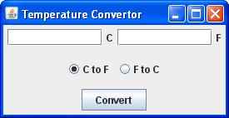

Initially “C to F” radio button (JRadioButton) will be selected but the user can select any one of the two. If the user selects “C to F” and presses convert button (JButton), the program will expect a temperature value from user in the left text field (JTextField) i.e. for C, and will output the equivalent temperature in F on the right text field. If the user selects the “F to C” radio button and presses convert button, the program will expect a temperature value from the user in the right text field and will output the equivalent temperature in C on the left text field. The program should handle common user exceptions during input like if he enters a text instead of a number for the temperature. It should report the problem in a message box. The equation for temperature conversion is:
C/5 = (F- 32) / 9

Question 4 [30 points]
- Design and implement a complete Java program that draws the following colored beach ball (use any 8 random colors):

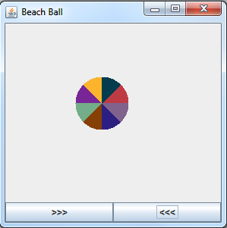

Each click on the left button moves the ball to the left by 5 pixels, and each click on the right button moves it to the right by 5 pixels.

- Then write the complete steps to convert the above program to an Applet, also write the HTML tag to insert the Applet in a Web page.

